Tatton Wildlife Newsletter – Summer

The long summer days are perfect for spending time out in the parkland and enjoying the wonderful nature on offer. This is the season to appreciate our various wildflowers and insect species. Animals and birds are busy raising young and it’s a great opportunity to relax and observe their interesting behaviour.

Birds

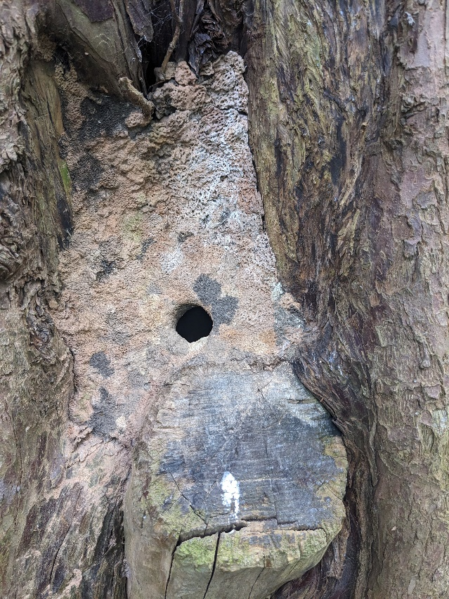 It is now nesting time for the birdlife in the parkland as they take advantage of the abundance of food, the longer daylight hours and better weather. Birds become more secretive, protecting their young and trying to avoid detection by predators. Fourteen pairs of herons nested at the heronry at Higmere which is an average number. One evening in April, they were joined by a little egret which are known to nest among heronries.

Deer

The deer are now calving and are very susceptible to disturbance. The hind or doe will drop the calf or fawn, respectively, in a clump of nettles or by a fallen branch then leave it, returning at night to feed it. This is why, if you do come across one, you must leave it alone. The calf or fawn has no scent and will not defecate thus preventing detection from predators. After a few days it will be able to follow the mother.

The russet colouration of the red deer and speckled, lighter coat of the fallow deer are now looking resplendent as they have moulted to their summer pelage. We also have varieties of dark melanistic and light leucistic fallow deer.

Woodland Life

Walking through many of Tatton’s wooded areas will reveal trees with cavities – all capable of hosting a varied and specialised community of animals. There are many ways in which the holes can be formed, for example – storm damage, fungi or excavation by animals.

The most obvious inhabitants of the dry tree holes are birds, many of which use the hollows for nesting. Tawny owls and little owls will occupy the larger holes while starlings, blue tits, and nuthatches the smaller ones. Nuthatches are noted for the way in which they reduce the size of the nest hole entrance with mud to keep out larger intruders - see the photo above of a nuthatch nest found in one of our woodlands!

Butterflies and Flowers

Spring and early summer has seen the ranger team begin the annual butterfly transect survey. Over the past five years, twenty species have been identified. Poor weather has seen a very quiet start to this year’s survey, with only small numbers of orange tip, peacock, comma, and green-veined white seen so far.

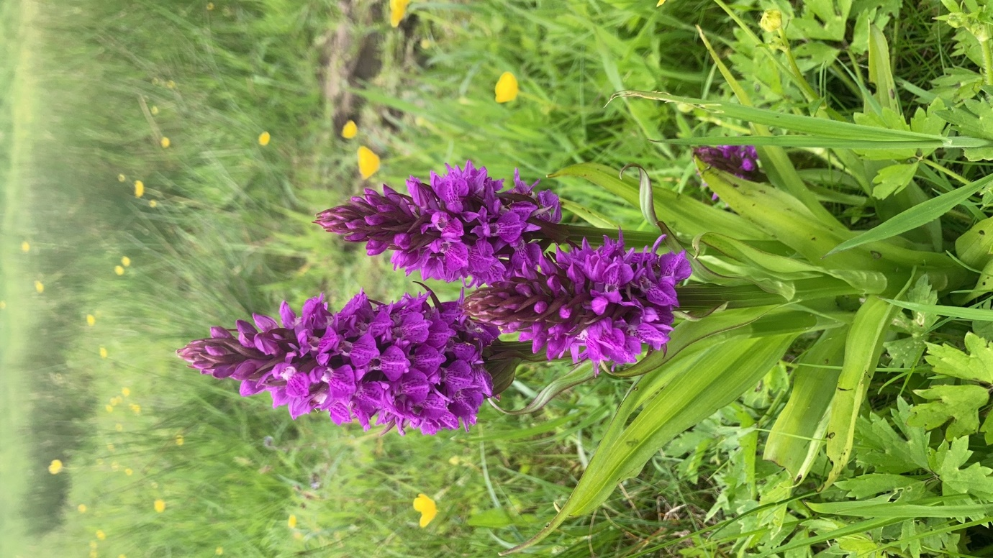 Hopefully things will start to improve as more plants emerge. Flowers are vital to butterflies, providing the nectar which they live on and the food plants on which they lay their eggs. These can be very specific, for instance, alder buckthorn required by the brimstone. Other species can use a wider number of hosts.

Providing a wide variety of flora is important to butterflies. Some areas around the car park have now been planted with wildflowers like yellow rattle, poppies, cornflower and many more. In other places we encourage a wilder, unkempt look such as stands of nettles that are very important for small tortoiseshell, peacock, and red admiral.

In less grazed areas, marsh orchids can be found.

***Compiled by Tatton’s Ranger Team***